Installing a Conda Environment – Easy steps for Windows

1. Download and install either Miniconda or Anaconda.

<https://www.anaconda.com/products/individual#Downloads>

<https://docs.conda.io/en/latest/miniconda.html>

1. Make a directory on your computer – for example in a folder called Image Downloader Project in your user directory.
2. Download the imagedownloader_env.yml from the GitHub repository and place it in the folder you created.
3. Click the “Windows” button at the bottom left of your taskbar open the command prompt with “cmd” or “Anaconda Prompt”. Select either the Anaconda Prompt or Miniconda Prompt depending on what you installed.

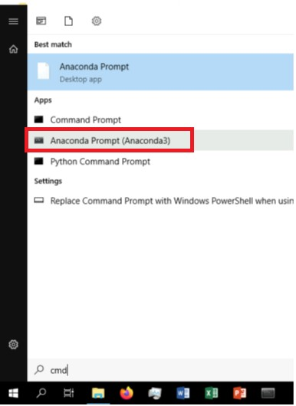

1. Type in cd (to change directory) and enter the name of the directory you just created.

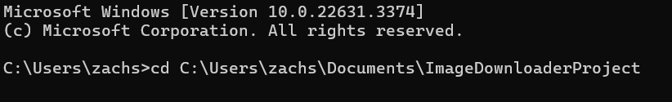

1. Then type this line: **conda env create --file imagedownloader_env.yml**



1. This will take some time to create the environment, take a break but make sure that your computer does not fall asleep.



1. Once it finishes you can test by going into the environment by typing:

**conda activate imagedownloader** (This will activate the environment) or **conda env list** (This will give you a list of all the conda environments on your computer)